Name : Ekta Narayan Sawant
Batch : T22
Roll No : 2401103
Experiment No. 5
Connecting a GitHub Repository to Jenkins for Continuous Integration
Aim
To connect a GitHub repository to Jenkins and configure a Pipeline job that automatically checks out and builds source code from the repository, and to troubleshoot a real source-control configuration error encountered during setup.
LO Mapped : LO3
Theory
Connecting Jenkins to a hosted Git repository such as GitHub allows a Pipeline job to pull the latest source code automatically instead of relying on code copied onto the Jenkins server manually. This is done by pointing the job's Pipeline definition to “Pipeline script from SCM,” selecting Git as the SCM, and supplying the repository URL along with a credential Jenkins can use to authenticate (for example, a personal access token, or a GitHub App registered as a Jenkins credential). Jenkins can then be told to check for new commits either through an inbound webhook from GitHub or through periodic polling (Poll SCM) configured with a cron-style schedule. A common configuration error at this stage is a branch-name mismatch: Jenkins defaults to looking for a branch called master, while most modern GitHub repositories use main as the default branch, which causes the checkout step to fail even though the credentials and repository URL are correct.
Steps Followed
I. Jenkins Dashboard: began from a clean Jenkins dashboard at http://localhost:8080, confirming no jobs or builds were queued before creating a new Pipeline item.
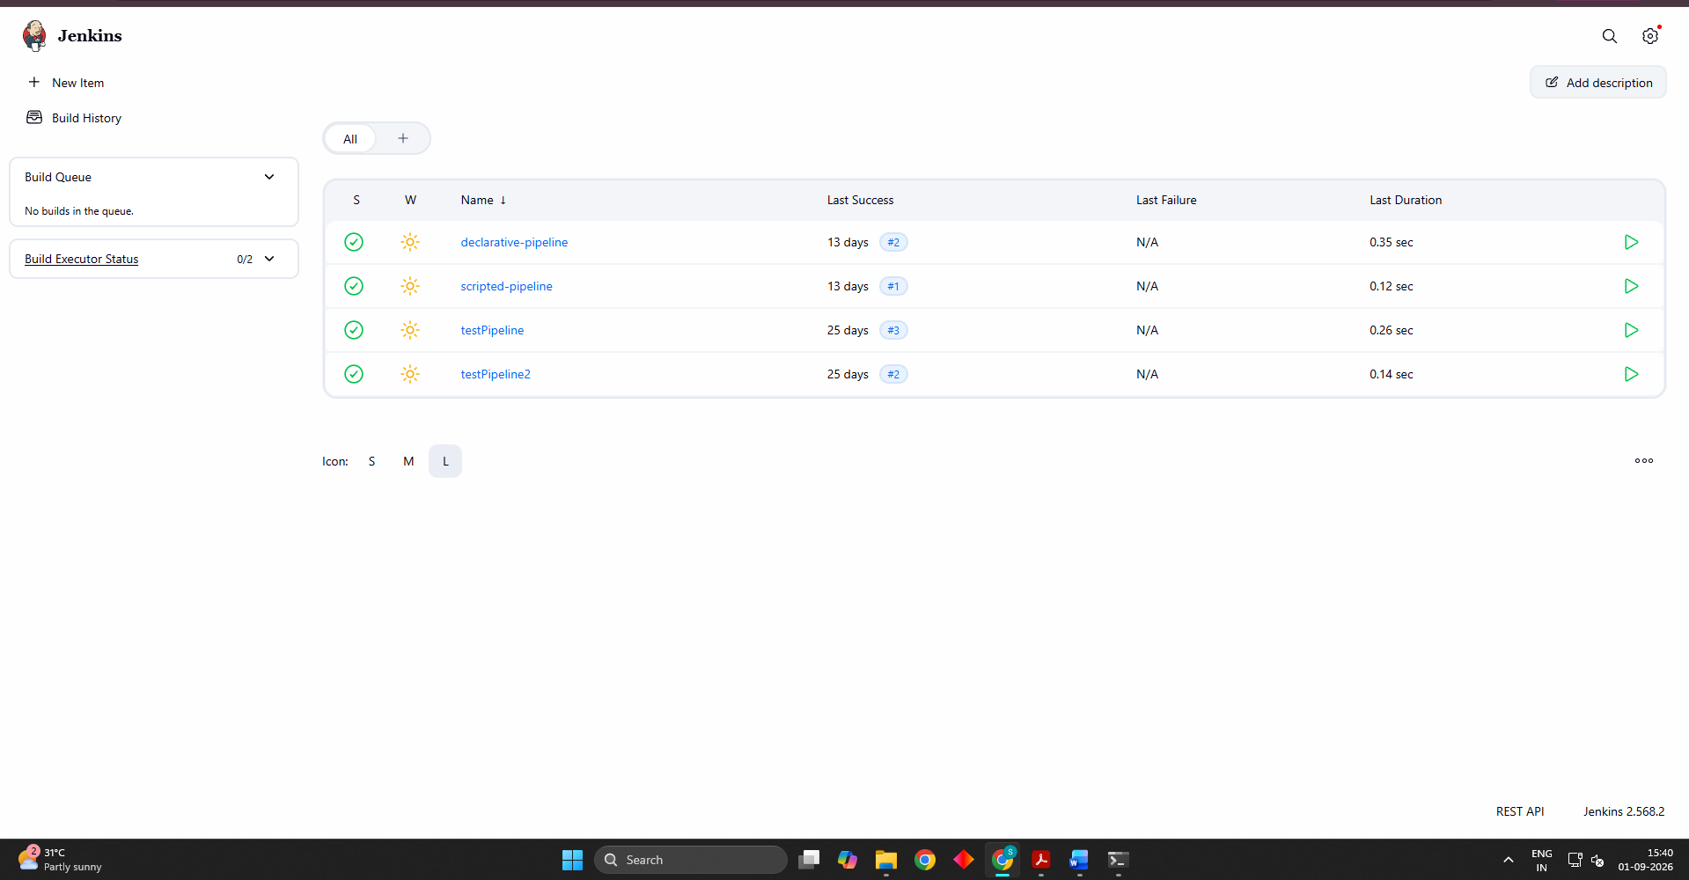
II. Exploring Credential Options: while configuring source-control access for the pipeline job, the “Add GitHub App” credential type was explored in Jenkins Credentials as an alternative authentication method to a personal-access-token credential, using an App ID and private key instead of a username/token pair.
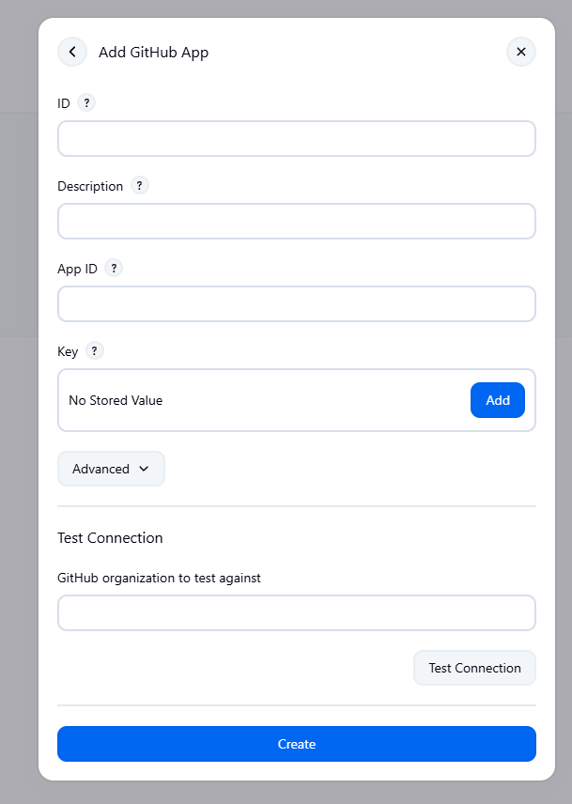
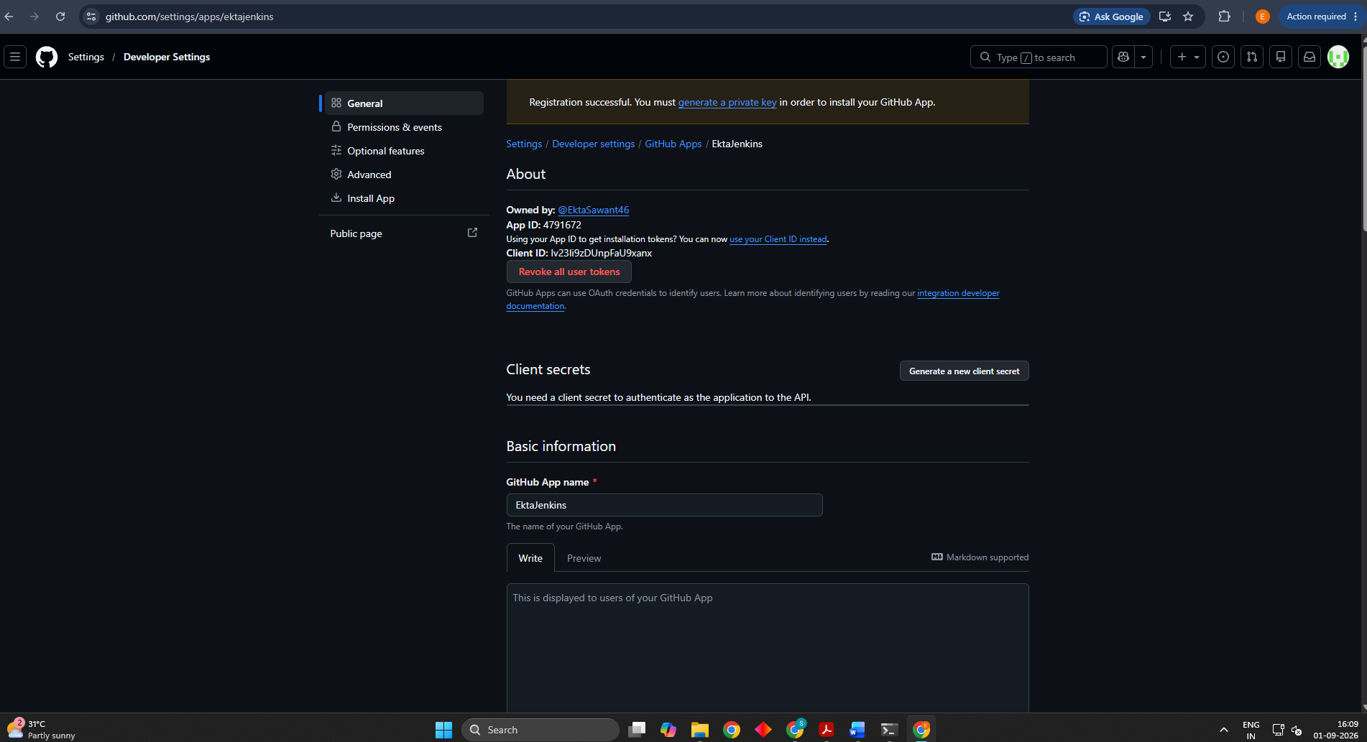
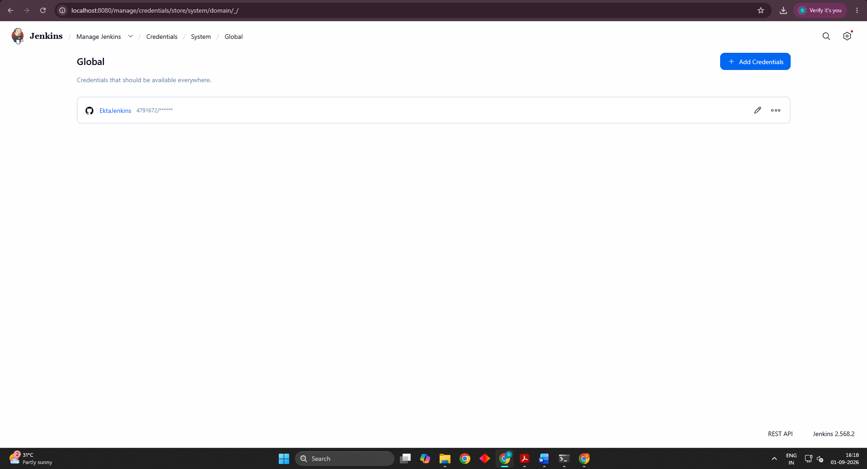
III. Pipeline Job Creation: a new Pipeline job named shivamkipipeline was created, with its Pipeline definition set to “Pipeline script from SCM,” SCM set to Git, and the repository URL pointed at the GitHub project.

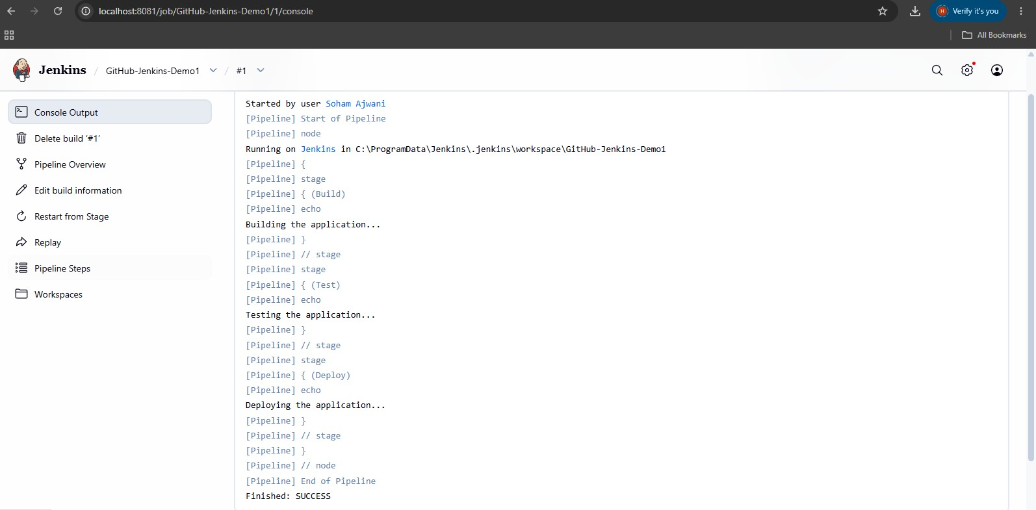
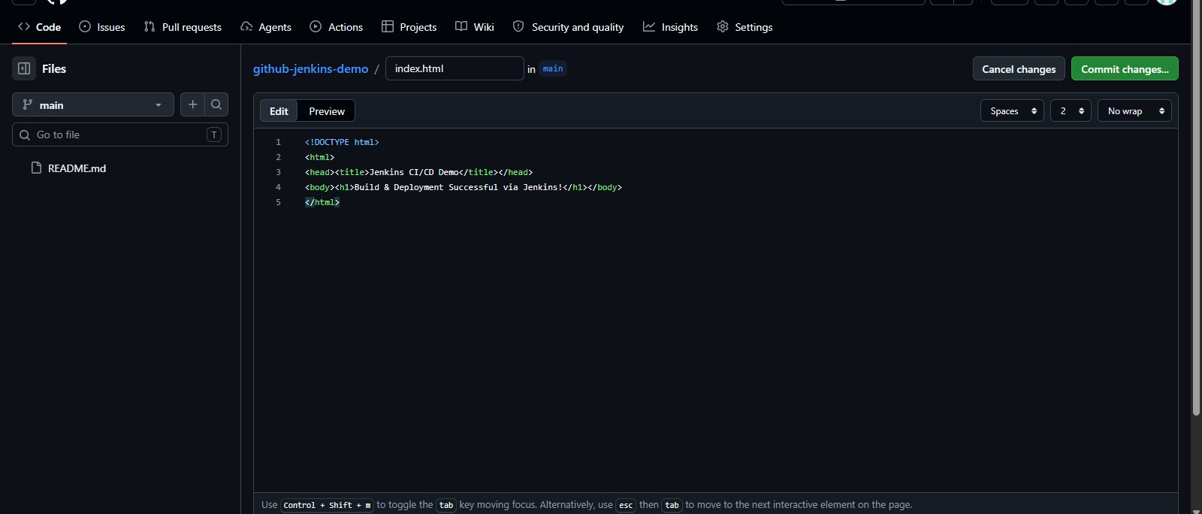

Part 5 — Connecting Jenkins to GitHub
In the job's Configure page, under Triggers, the 'GitHub hook trigger for GITScm polling' option is enabled so that a push to GitHub automatically triggers a Jenkins build.
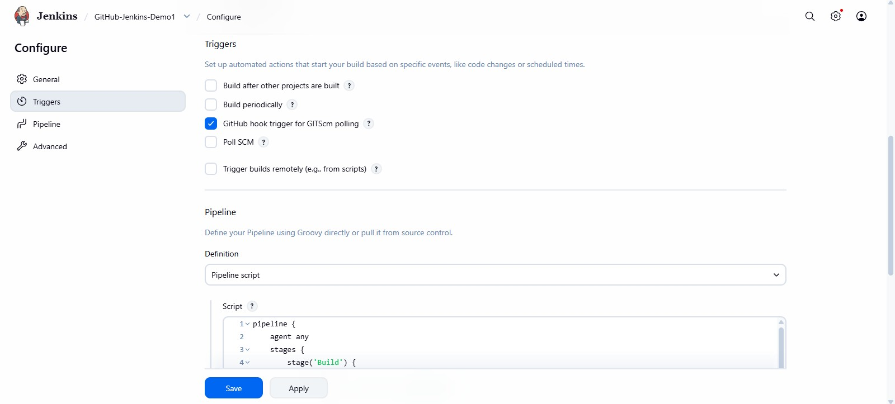
Fig 11: Enabling the GitHub hook trigger under Triggers
Under the Pipeline section, the Definition is changed from Pipeline script to Pipeline script from SCM, and the Script Path is set to Jenkinsfile.
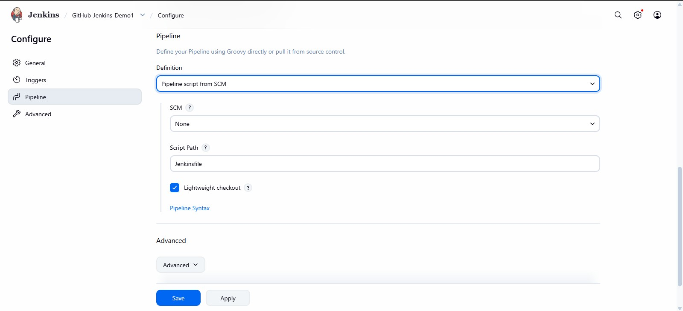
Fig 12: Setting the Pipeline definition to 'Pipeline script from SCM' with Script Path 'Jenkinsfile'
The SCM is set to Git, and the GitHub repository URL (https://github.com/sohamajwani/githubjenkins-demo.git) is entered.
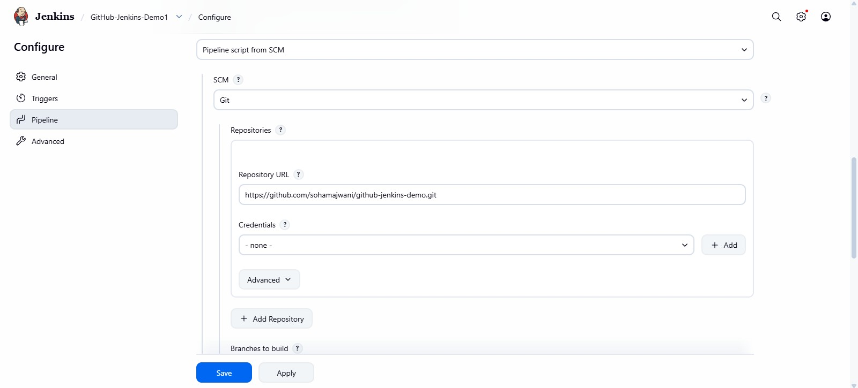
Fig 13: Configuring the Git repository URL under SCM
The Branch Specifier is set to */main and the Script Path is confirmed as Jenkinsfile, after which the configuration is saved.
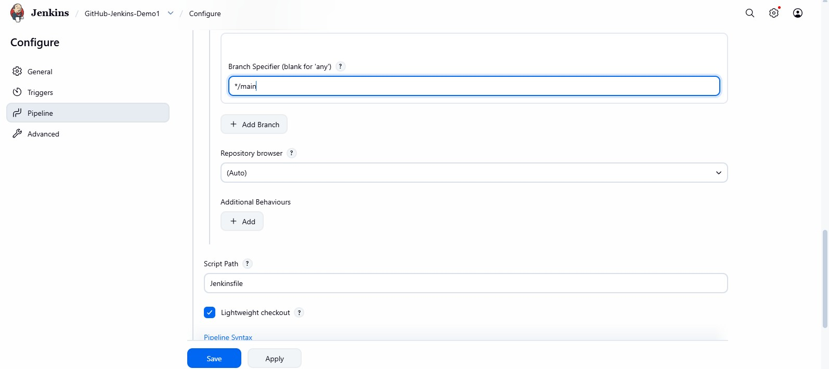
Fig 14: Setting the branch specifier to */main and confirming the Jenkinsfile path

Part 6 — Verifying the GitHub-Triggered Build
After saving, the pipeline status shows the last build, last stable build, and last successful build details for the job.
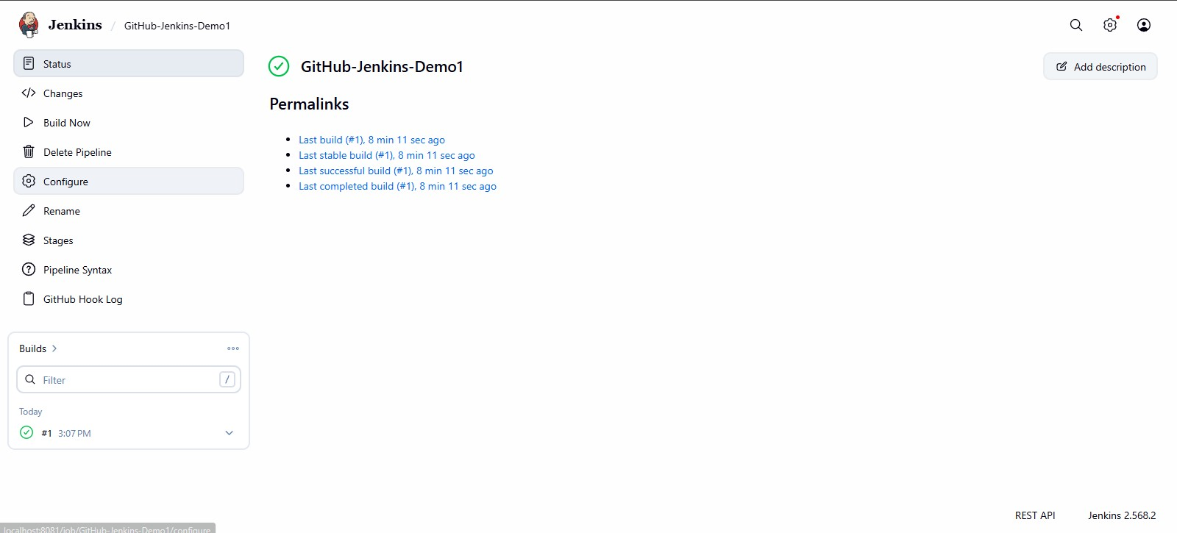
Fig 15: Job status page showing successful build history after SCM configuration
Triggering the build again schedules a new run of the pipeline sourced from GitHub.
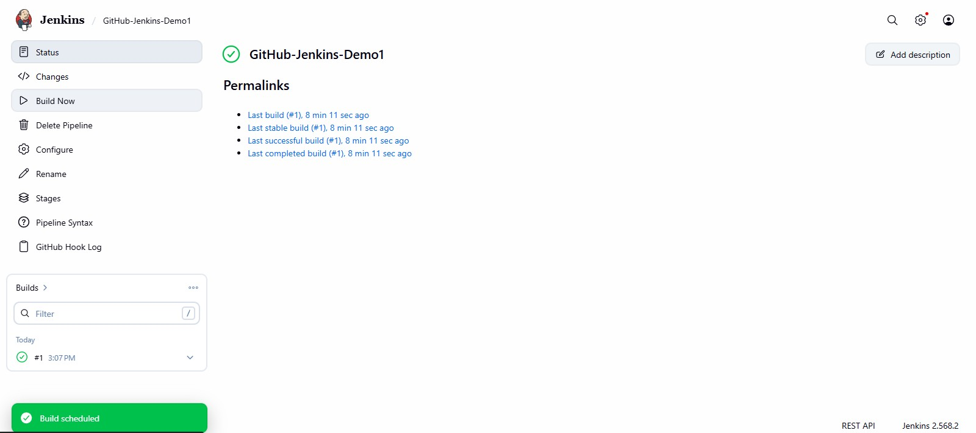
Fig 16: 'Build scheduled' notification for the GitHub-sourced pipeline
Build #2 completes successfully, and its Console Output is opened from the build menu.
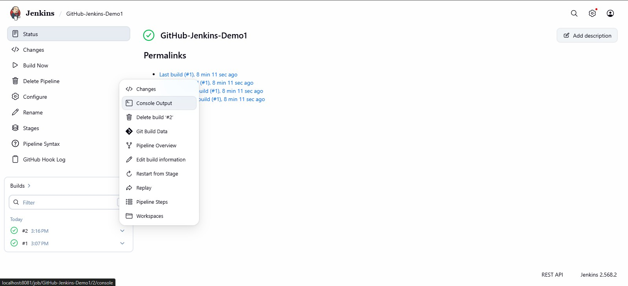
Fig 17: Build #2 completed; opening Console Output from the build menu
The console output shows Jenkins obtaining the Jenkinsfile directly from the GitHub repository and cloning it into the local workspace, confirming the SCM integration is working.
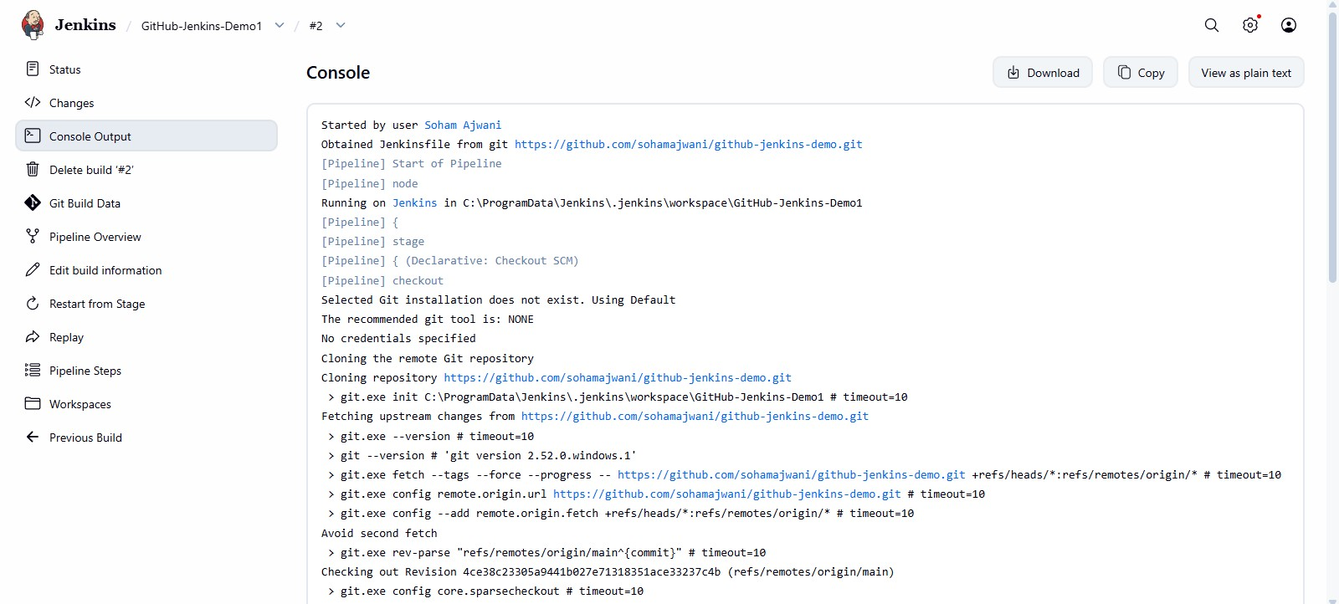
Fig 18: Console output showing Jenkins cloning the repository and obtaining the Jenkinsfile from GitHub
Jenkins checks out the latest commit from the main branch and executes the Build, Test, and Deploy stages defined in the Jenkinsfile.
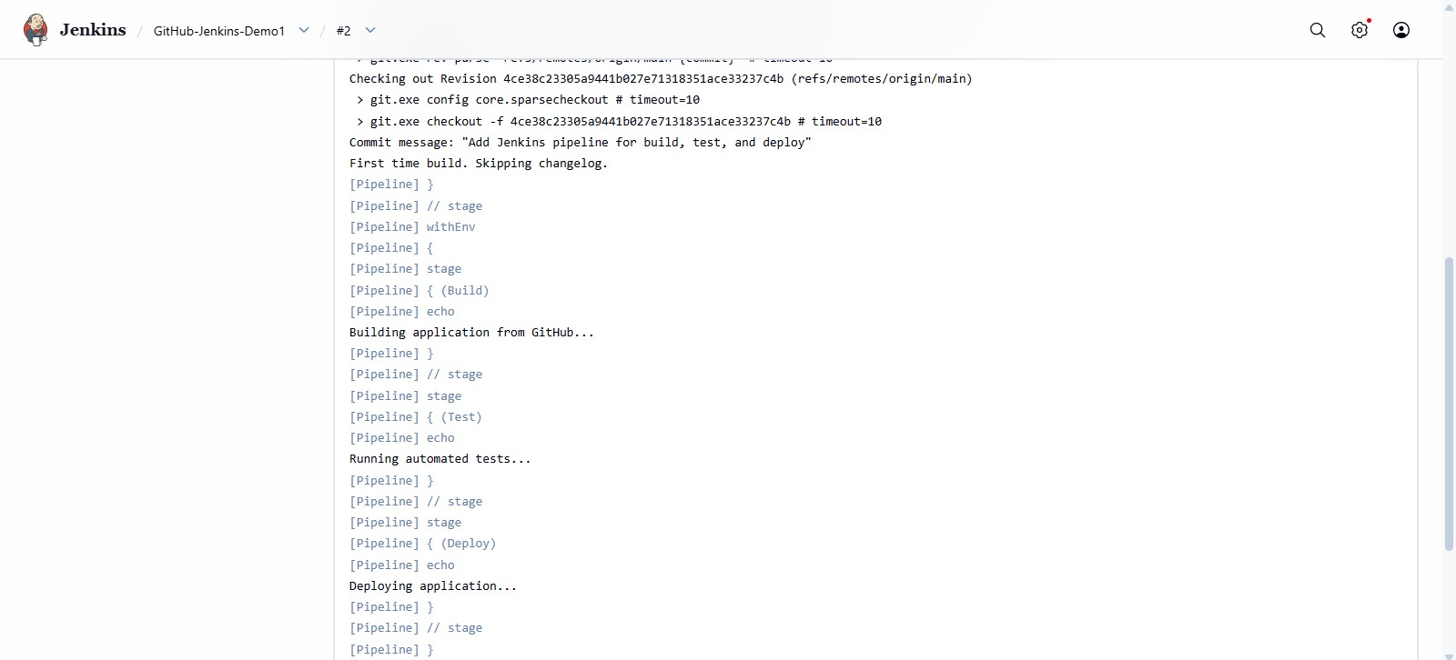
Fig 19: Checkout of the latest commit followed by execution of Build, Test, and Deploy stages
The pipeline completes all stages and finishes with status SUCCESS, confirming that the full GitHub → Jenkins CI/CD flow works end-to-end.
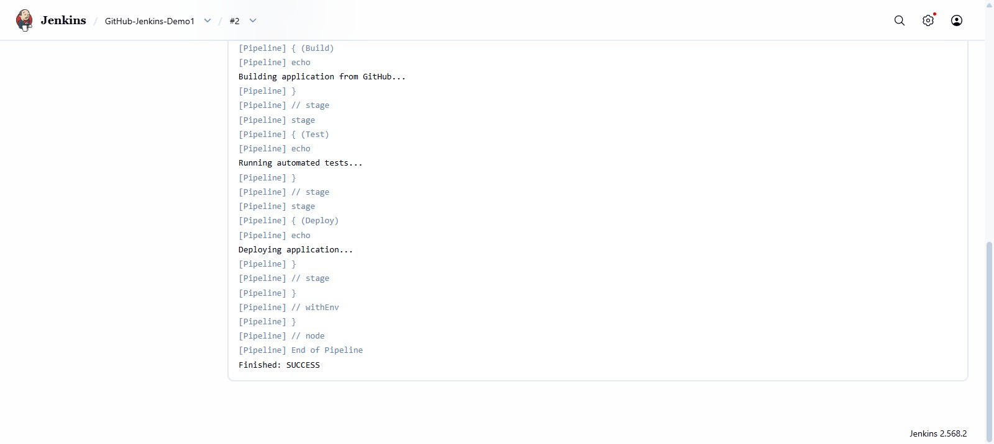
Fig 20: Pipeline execution completed — 'Finished: SUCCESS' for the GitHub-triggered build
Conclusion
By this assignment, a GitHub repository was successfully connected to Jenkins through a Pipeline job configured with “Pipeline script from SCM.” Along the way, an alternative GitHub App credential option was explored, and a genuine configuration error — a mismatch between Jenkins' default master branch expectation and the repository's actual main branch — was diagnosed directly from the console output and resolved by updating the job's branch specifier, after which Jenkins successfully checked out the correct revision from the repository.

